A Level Psychology Summer Task 2020
At Teignmouth Community School we study the Edexcel specification. At the end of year 13 you will take three exams, each two hours long. Throughout the course you will study the different areas of Psychology outlined below. Within each unit there will be theories and studies to learn, research methods and a practical to carry out, and an essay to apply your learning from Psychology to real life examples.
Course overview:
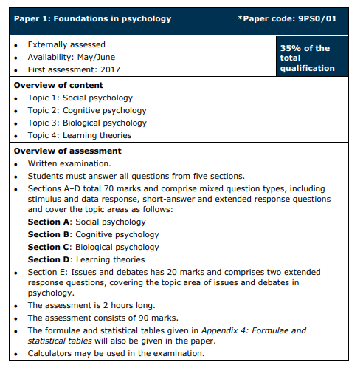
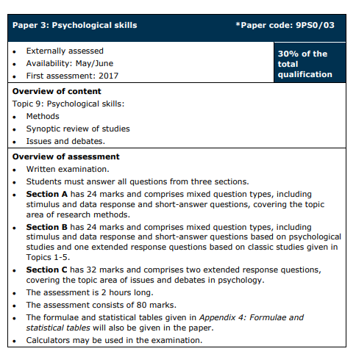
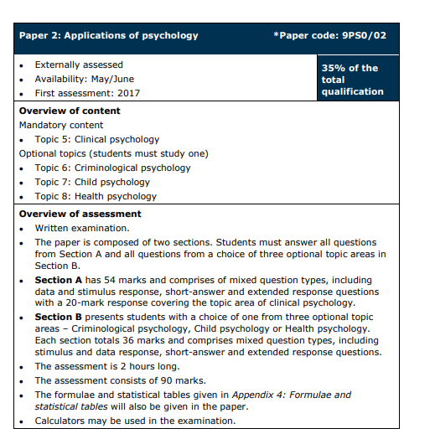

This pack will help you gain an understanding of just some of the different areas of Psychology you will be studying. The tasks are split into three levels – challenge 1, challenge 2 and challenge 3. It would be good practice to attempt all tasks – do not be afraid if you find it hard. As a minimum all challenge 1 criteria must be completed, you should complete the challenge 2 criteria and it would be good practice to attempt the challenge 3 criteria.

Task 1: Social Psychology
Challenge 1
1) Research and produce a fact sheet on one key study - Milgram’s (1963) Obedience to Authority
Challenge 2
2) Explain how research such as Milgram might explain historical atrocities such as the Nazi persecution of the Jews
Challenge 3
3) Discuss any problems you can identify with this study and using it to explain atrocities
Task 2: Cognitive Psychology – Memory
Mini Experiment:
In this experiment you can test as many or as little people as you like. As the experimenter you should read out one line at a time of the triangle of numbers below to your participant. When you have finished reading out the line, your participant should recite back to you as many of the numbers they can remember. Record how many numbers they recall correctly on each line.

Now think about and explain:
- What was the maximum amount of numbers your participants call recall from any line? (If you used more than one participant, take the average).
- What do your results suggest about memory?
Now research and answer the following…
Challenge 1
- What is memory? Does it have different types? If so, explain them…
- What is the capacity and duration of the average memory in humans?
Challenge 2
- What did George Miller do in 1956? What did he discover about memory? How does this link to the results from your experiment above?
Challenge 3
4) Explain why psychologists are interested in studying memory. Think about why it is useful in society to know about human memory

Task 3: Research Methods in Psychology
Psychological theories are based on scientific evidence. Evidence can be collected in a variety of ways.
Challenge 1
Describe each of the methods below that are used in psychology. Include how the psychologist would use each method to collect their data
Challenge 2
Evaluate each method. This means strengths and weaknesses. Can you come up with two strengths and two weaknesses for each?
Challenge 3
Carry out some research to see if you can find any examples of psychological research that uses each method. Try and look for famous/well known examples

Possible way to complete this task:
Research Method | How a psychologist would use it | Evaluation (aim for 2 strengths/2 weaknesses) | Example of research
Questionnaires
Interviews
Laboratory experiment
Field experiment
Observations
Correlations
Animal studies

Task 4: Biological Psychology
Challenge 1
Define nature and nurture. Explain which biological psychology would fit in with and why
Challenge 2
Use your prior knowledge from science to draw and label a neuron
Use your diagram of the neuron to help explain how messages are sent around the body
Challenge 3
Research 3 different neurotransmitters and explain their role

Task 5: Learning approach (behavioural psychology)
Challenge 1
Who is your role model? What is it that makes them a role model? If you do not have one, think about other people and who their role models might be and why
Challenge 2
Describe how we learn behaviour from watching a role model – you could research social learning theory to help you
Challenge 3
Explain why it is useful to understand whether we learn through observation of others. Think about how this knowledge could be used in society.

Task 6: Research Methods – extra challenge!
Mann Whitney
Mann Whitney is a statistical test used when you are researching a difference between conditions and when you have independent groups. I am interested in whether it is worth buying a more expensive brand of cookies or if I should buy the value product. This would be a test of difference as I am comparing the two items, and it is independent as I am looking at value and expensive brands.
The steps below will help you calculate whether or not there is a statistically significant difference between the number of chocolate chips in the value or more expensive range, or whether any difference is due to chance.
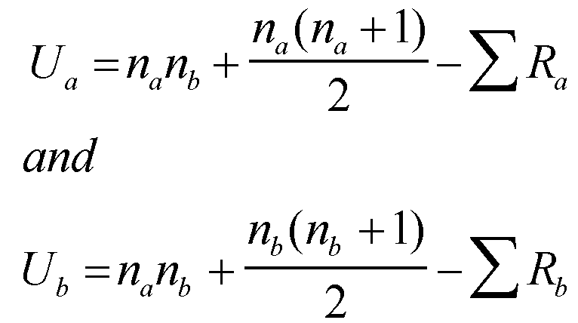
N = number in a group
N_{a} = number in Condition 1
N_{b} = number in Condition 2

To calculate the Mann-Whitney U you have to rank the scores from smallest to highest.
R= the sum of ranks for scores in each condition
R_{a} = total for Condition 1
R_{b} = total for Condition 2

Data you can use to have a go at carrying out the Mann Whitney test:
Value Cookie | No of choc chips | Expensive cookie | No of choc chips
1 | 9 | 1 | 12
2 | 8 | 2 | 16
3 | 12 | 3 | 13
4 | 7 | 4 | 17
5 | 7 | 5 | 12
6 | 11 | 6 | 10
7 | 6 | 7 | 11
8 | 10 | 8 | 14
9 | 6 | 9 | 11
10 | 5 | 10 | 15
Mean |  | Mean
Median |  | Median
Mode |  | Mode
Range |  | Range

Step 1. Enter the data I have collected. You should then rank these in order from lowest to highest. If there is more than one cookie with the same number of chocolate chips you need to add together the ranks (not the number of cookies) and then divide by the number of ranks e.g. if there were 3 cookies that would be ranked 7,8,9 you would add 7,8 and 9 to get 24, and then divide by 3 and give each a rank of 8. You then continue the ranks with the next number, in this example 10.
Value cookie | No of choc chips | Rank (for all cookies) | Expensive cookie | No of choc chips | Rank (for all cookies)
1 |  |  | 1
2 |  |  | 2
3 |  |  | 3
4 |  |  | 4
5 |  |  | 5
6 |  |  | 6
7 |  |  | 7
8 |  |  | 8
9 |  |  | 9
10 |  |  | 10

Step two. Add the ranks for the value cookies. ∑R_{a} = ______________
Step three. Add the ranks for the expensive cookies. ∑R_{b} = ______________
Step four. Multiply N_{a} by N_{b} Number of value cookies x number of expensive cookies = _________________________________________________________________

Step five. To calculate U_{a}
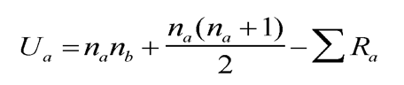
Add 1 to the number of value cookies and then times this by the number of value cookies. Divide this number by 2.

Add together this number with the number from step 4.

You then subtract your answer from step 2 from the answer above. This number is then your U_{a}

Step 6. You now need to calculate U_{b}
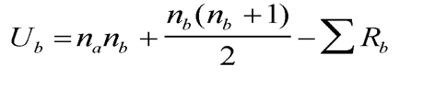

Add 1 to the number of expensive cookies and then times this by the number of expensive cookies. Divide this number by 2.

Add together this number with the number from step 4.

You then subtract your answer from step 3 from the answer above. This number is then your U_{a}

The smaller value of U_{a} and U_{b} becomes U. This is called your observed value. You then use a critical value table to see if it is significant. Your U value must be lower than the value in the table to be significant.
If we predict more expensive cookies have more chocolate chips this is a direction hypothesis – also known as one tailed. Psychologists work with the probability level of 0.05 – this means that there is only a 5% likelihood the results are due to chance, and not the variable being studied.
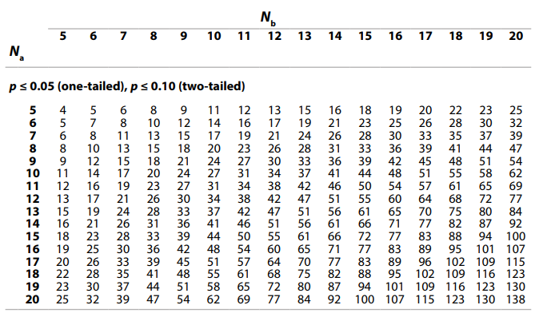

The calculated value must be equal to or less than the critical value in this table for significance to be shown.

In our experiment, the observed value for U was _________
N_{a} is _____ and N_{b} is ______
The critical value is ______ (this is the value in the table above)
As U was higher/lower it is therefore not significant/significant

Useful sources
Websites:
- www.psychologyrocks.com
- http://www.simplypsychology.org
- http://www.psychologywizard.net
- https://qualifications.pearson.com/en/qualifications/edexcel-a-levels/psychology-2015.html
Books:
- Obedience to Authority – Stanley Milgram
- Psychology: The Science of the Mind and Behaviour – Richard Gross
- Edexcel AS/A Level Psychology – Karren Smith

- Edexcel Psychology A Level Year 1- Christine Brain

- Edexcel Psychology for A Level Year 1 – Cara Flanagan, Matt Jarvis, Rob Liddle, Mandy Wood

Mann Whitney Help
Worked Example
Step 1 Rank Data
Participants (Na=6) | Scores for females | Rank (for all participants) | Participants (Nb=7) | Scores for males | Rank (from all participants)
1 | 123 | 13 | 1 | 95 | 8
2 | 89 | 5 | 2 | 78 | 2
3 | 140 | 14 | 3 | 102 | 10
4 | 97 | 9 | 4 | 79 | 3
5 | 110 | 12 | 5 | 84 | 4
6 | 150 | 15 | 6 | 93 | 7
7 | 104 | 11 | 7 | 62 | 1
 |  |  | 8 | 92 | 6
Step 2
Add ranks for A: ∑R_{a} = 79
Step 3
Add ranks for B: ∑Rb = 41
Step 4
Multiply N_{a} by N_{b} 7 x 8 = 56
Step 5
Add 1 to N_{a} multiply the result by N_{a} (7 + 1) x 7 = 56
Divide this answer by 2 56/2= 28
Add together with your answer from step 4 56 + 28 = 84
Then subtract your answer from step 2 84 – 79 = 5
This is U_{a} U_{a} = 5
Step 6
Add 1 to N_{b} multiply the result by N_{b} (8 + 1) x 8 = 72
Divide this answer by 2 72/2= 36
Add together with your answer from step 4 56 + 36 = 92
Then subtract your answer from step 3 92 – 41 = 51
This is U_{b} U_{b} = 51
The smaller value of U_{a} and U_{b} becomes U. In this case the U value is 5 (U_{a}=5, U_{b}= 51)

