Forming and Solving Linear Equations
Multiplying a number by 5 and adding 3 is the same as subtracting 6 from the number and multiplying the result by 2. What is the number?

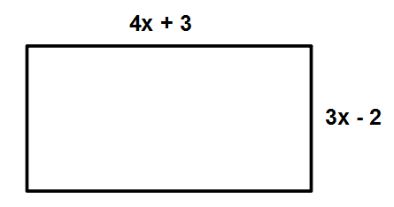
This rectangle has a perimeter of 9cm. Form an equation to find the value, in cm, of x.

Prove that the sum of two consecutive odd numbers is even.

Prove that the sum of any three consecutive even numbers is a multiple of 6.

Prove that when two consecutive numbers are squared, that the difference is equal to the sum of the two consecutive numbers.

