Welcome to the A LEVEL Photography course here at TCS. We are looking forward to working together and producing a developed skills-based portfolio. Throughout the two-year course we will be exploring a wide range of skills and processes to build your knowledge and understanding. As the weeks go on we expect you to be working independently and self-direct. The expectation is that you are working at home and during your study periods. The induction task is a good example of how you might manage your time and prepare for the future lessons.
A Level Photography Induction Task

**********************
To prepare for the start of term we would like you to complete a task that will:
• Show the department what you are already capable of;
• Remind you of what you are capable of;
• Stretch your photographic skills and develop your experiences outside of the classroom.
You will need to present this to your teacher at your first Photography lesson. Failure to do so will impact on your probation outcome.
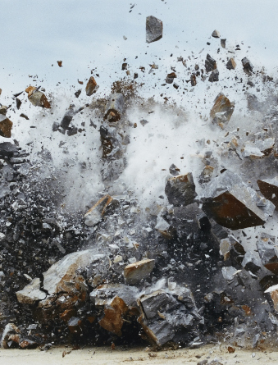
Task One: Response to Senses
Create your own series of photographs exploring each of the 5 senses. You can use whatever editing techniques and processes you feel most appropriate, and you should also think about how you could present your images to enhance the sensory experience of the viewer. Don’t worry if you don’t have a DSLR camera, a good mobile phone camera will work. Use these Photographers as inspiration: Keith Arnatt, Naoya Hatakeyama, Jane Fulton Alt, Rolf Sachs
Task Two: Gallery/Museum Visit.
Present on A3 paper or 2 sheets of A4, a trip that you have made to see an exhibition. This could be Local (RAMM Exeter) or National (London, Bristol). You must include 500 words (typed or written) analysing a piece of art work by an artist or the exhibition that you saw. You must include photographs or postcards from the visit.
We are looking for: Presentation skills – how create and imaginative can you be? Observational photography skills – how well you have explored composition, lighting, angles, vantage points and the quality of written work. Have you described, explained and analysed.

